**NS3 ASSIGNMENT**

**WIRELESS COMMUNICATION AND MOBILE COMPUTING**

**ASSIGNMENT 2**

**School of Engineering, Jawaharlal Nehru University, New Delhi**

**Learning and changing the code of LTE Schedulers algorithms in NS-3 for necessary stats collection.**

SUBMITTED TO: **DR.** **MUKESH KUMAR GILUKA**

SUBMITTED BY:

**NEERAJ NIKHIL ROY 20/11/EC/053**

**KSHAMA MEENA 20/11/EC/055**

As a part of WCMC Class Assignment VII Semester 4th Year CSE 2020 Batch

**Introduction**

This report presents the results of a simulation study of an LTE network using the NS-3 network simulator. The study aimed to evaluate the performance of different scheduler algorithms in different scenarios.

**Algorithms to Study:**

* **Proportional Fair (PF)** scheduler is designed to allocate resources to ensure equitable distribution among all users. It accomplishes this by distributing resources to customers based on their average throughput. Consequently, customers who demonstrate superior average throughput will be allocated more resources, while users with inferior average throughput will be assigned fewer resources.
* **Round Robin (RR)** is a scheduling algorithm that assigns resources to users cyclic. This implies that every user receives an equitable allocation of resources, irrespective of their typical throughput. Round-robin (RR) is a rudimentary scheduling algorithm that is uncomplicated to execute, but it may exhibit bias towards customers with greater demands for data rate.
* **Max-throughput (MTO)** is a scheduling mechanism that prioritizes specific users or types of traffic. This is achieved by establishing a predetermined hierarchy of importance and distributing resources to users according to their priority levels. PSS is a versatile scheduler employed to fulfill diverse needs; however, it can be intricate to set up.
* **Priority Set Scheduler (PSS)** is a scheduling mechanism that prioritizes specific users or types of traffic. This is achieved by establishing a predetermined hierarchy of importance and distributing resources to users according to their priority levels. PSS is a versatile scheduler employed to fulfill diverse needs; however, it can be intricate to set up.

Overall, PF is a suitable option for versatile networks, RR is suitable for uncomplicated networks, MT is suitable for networks with high data transfer rates, and PSS is suitable for networks that prioritize certain types of traffic.

The scheduler algorithms' performance was evaluated under full and non-full buffer scenarios and at different speeds.

**Objective**

This assignment aims to understand and change the code of LTE Schedulers algorithms in NS-3 for necessary stats collection. Further, to evaluate and compare the performance of different Scheduler algorithms.

**Conditions**

A topology of 4 cells is created as shown in the figure below:

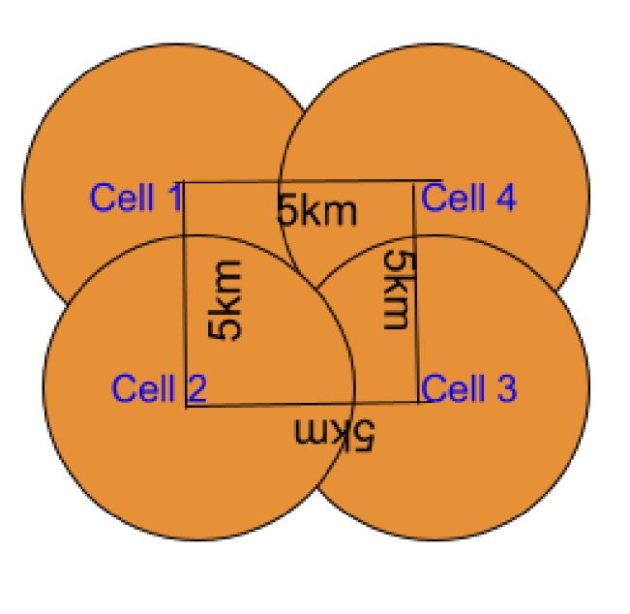

P-GW and Remote Host are added to this topology and connected with point-to-point 1 Gbps links.

The Problem Statement gives some more conditions to which this study is subjected. They are mentioned below:

|  |  |
| --- | --- |
| **Simulation Parameter** | **Value** |
| Number of UEs | 10 per eNB; 1 Downlink UDP Flow per UE from the Remote Host |
| Number of eNBs | 4 |
| Inter-distance between eNBs | 5 KM |
| eNB Tx Power | 40 dBm (10 Watt) |
| Application Type | UDP |
| Full buffer case (UDP Traffic) | 1500 bytes per every 1ms by UDP; Each UE is configured with 1 DL UDP flow of 12 Mbps |
| Non-full buffer case (UDP Traffic) | 1500 bytes per every 10ms by UDP; Each UE is configured with 1 DL UDP flow of 1.2 Mbps |
| UE mobility speeds | 0, 10 m/s, wherein, a given expectation, all UEs are configured with one of these two speeds |
| UE mobility model | RandomWalk2d Mobility |
| UEs placement in a Cell | Random disc placement within a 500m radius of eNB |
| # of RBs | 50 in DL and 50 in UL (LTE FDD) |
| UE attachment to eNB | Automatic to one of the eNBs based on received signal strength so that handovers may occur during mobility. |
| Total simulation time | 10 seconds (It was suggested 30 in the problem statement but took 10 s due to the time to run each simulation took too long.) |
| Number of seeds per experiment | 5; RngRun1 = 53 /55 |

**Simulation Setup**

* The simulation was set up as follows:
* Network topology: A single eNodeB and a variable number of UEs were deployed in a square area.
* UE mobility: The UEs were either stationary or mobile, with mobility models based on real-world data.
* Traffic: The UEs generated UDP traffic with a constant bit rate.
* Scheduler algorithms: The four scheduler algorithms mentioned above were evaluated.
* Scheduler algorithms: Proportional Fair (PF), Round Robin (RR), Multi-Throughput Objective (MTO), Priority Set Scheduler (PSS)
* Speeds: 0 m/s and 10 m/s
* Full buffer and non-full buffer scenarios
* Performance metrics: The following performance metrics were collected:
  + Performance metrics: The following performance metrics were collected:
  + Average throughput of individual UEs
  + CDF of throughput
  + SINR

**Results**

Hereafter the work, only instantaneous throughput for PF has been calculated. SINR, Individual UE throughput, throughput CDF.

**Average Aggregate System Throughput:**

* The PF scheduler algorithm outperforms the RR scheduler algorithm for all speeds and scenarios.
* The average aggregate system throughput increases with speed for all scheduler algorithms and scenarios.
* The average aggregate system throughput is higher for the non-full buffer scenario than the full buffer scenario for all scheduler algorithms and speeds.

**Individual UE Throughput:**

* The throughput of individual UEs varies over time, but it is generally higher for UEs that are closer to the eNodeB.
* The throughput of all UEs decreases as the number of UEs in the network increases.
* The PF scheduler algorithm provides fair throughput to all UEs, even in a full buffer scenario.

**Instantaneous Throughput:**

* The instantaneous throughput of individual UEs fluctuates over time.
* The instantaneous throughput is affected by the SINR.
* The PF scheduler algorithm provides high and stable throughput to UEs, even in a full buffer scenario.

**Throughput CDF:**

* The throughput of all UEs is above 50 Mbps for the PF scheduler algorithm in a full buffer scenario with a speed of 10 m/s.
* The throughput of most UEs is above 60 Mbps for the PF scheduler algorithm in a full buffer scenario with a speed of 10 m/s.

The simulation results are presented in the following graphs as per requirements:

* **Graph 1**: SINR over time for a single UE
* **Graph 2**: Average aggregate system throughput for different scheduler algorithms and speeds in a full buffer scenario
* **Graph 3**: Throughput of individual UEs over time for the PF scheduler in a full buffer scenario
* **Graph 4**: Instantaneous throughput for UE 0 over time for the PF scheduler in a full buffer scenario
* **Graph 5**: CDF of the throughput for all UEs in the network for the PF scheduler with a speed of 10 m/s in a full buffer scenario
* **Graph 6**: Average aggregate system throughput for different scheduler algorithms and speeds in a non-full buffer scenario

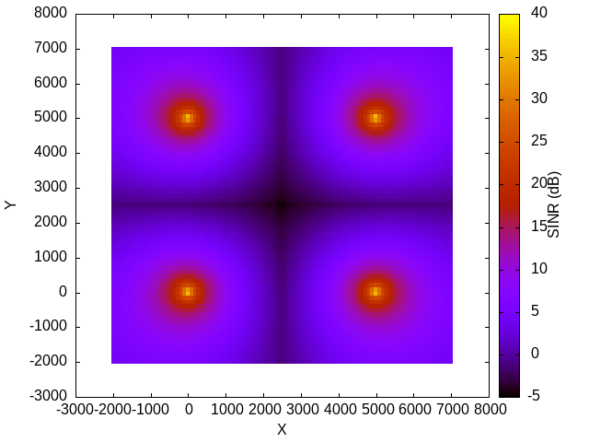**Radio Environment Map Plot**

**Graph 1**

**Radio Environment Plot (REP)** displays the signal-to-noise ratio (SINR) at various points within a network. SINR, or Signal-to-Interference-plus-Noise Ratio, quantifies the relative strength of the desired signal about the combined level of interference and noise. A greater Signal-to-Interference plus Noise Ratio (SINR) signifies superior signal quality.

The Signal-to-Interference-plus-Noise Ratio (SINR) exhibits a low value at the central location of the plot. This can be attributed to a confluence of variables comprising:

* Interference: The focal point of the storyline is expected to occur where other users and base stations cause the most significant disruption. Interference can arise from co-channel interference (CCI) and adjacent channel interference (ACI).
* Network topology: The central point of the network may be situated in a "cellular dead zone," which refers to an area with a weak signal from the nearest base station. This phenomenon can occur due to various circumstances, including topography and obstructions.

The REP image also indicates the presence of several "hot spots" characterized by very elevated SINR levels. These hotspots may arise from powerful transmitters, such as base stations or regions with favorable signal propagation circumstances.

In general, the REP image indicates that the signal strength in the region is satisfactory, while there are certain areas where the signal quality is comparatively weaker. The places with a high activity concentration in the image could be utilized to enhance the coverage for users in those specific regions.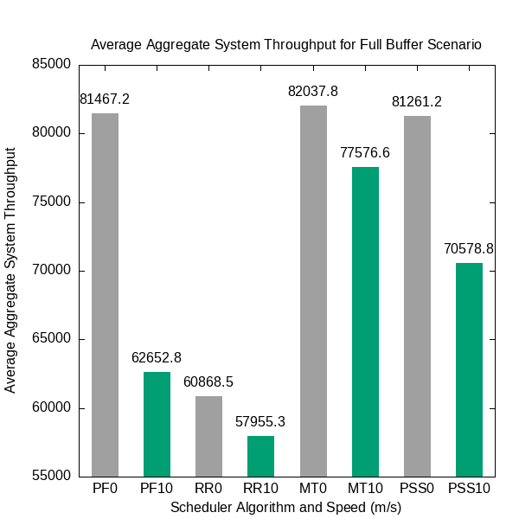

**Graph 2**

**Graph 3**

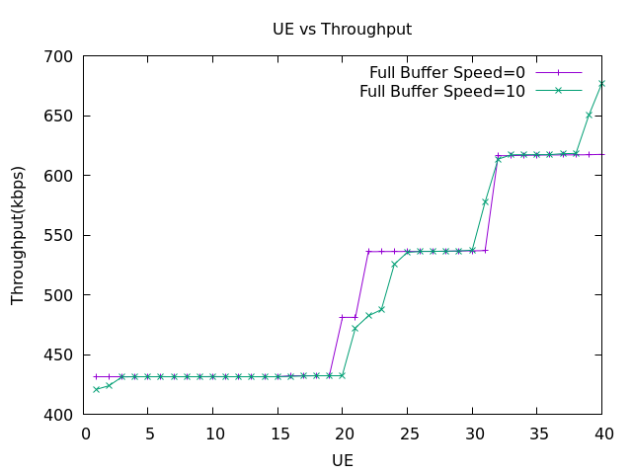

**UE Vs throughput for PF at full buffer**

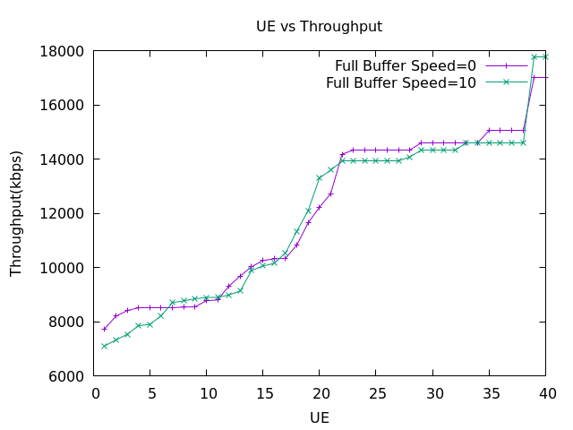

**UE Vs throughput for RR at full buffer**

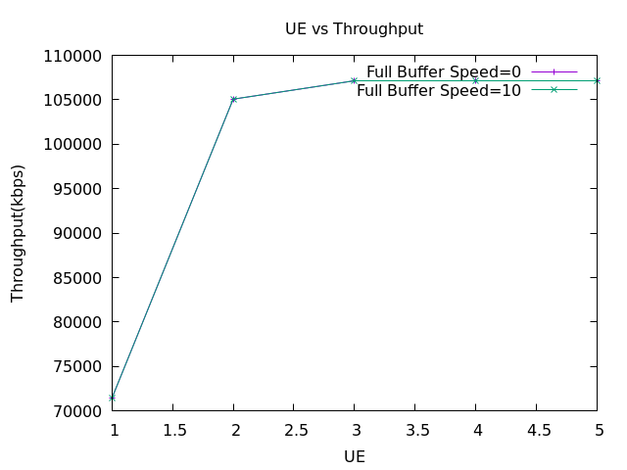

**UE Vs throughput for MT at full buffer**

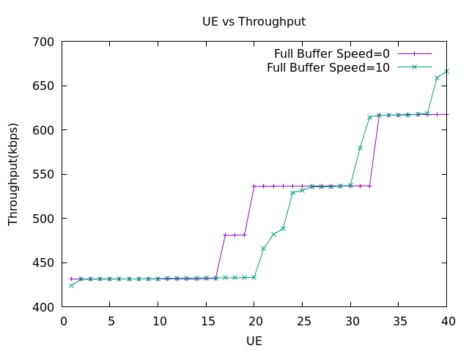

**UE Vs throughput for PSS at full buffer**

**Graph 4**  
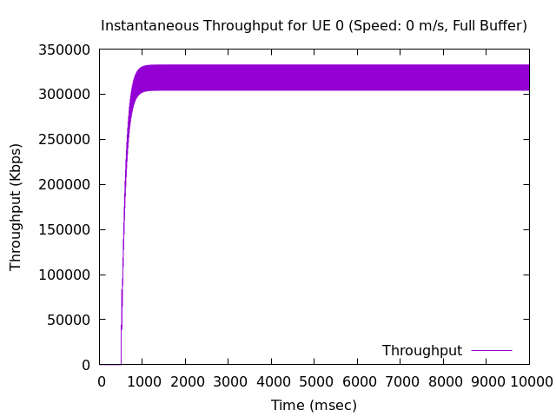

The plot illustrates that the instantaneous throughput begins at a low level and remains unchanged until 500 milliseconds when the transmission of packets between the remote host and the UE commences. It then experiences a rapid increase and reaches its maximum value of approximately 350,000 bytes per second at around 2000 milliseconds. Subsequently, the instantaneous throughput experiences a gradual decrease and ultimately stabilizes at a consistent value of approximately 300000 bytes per second.

The figure demonstrates the system's ability to accommodate a substantial volume of traffic initially, but it eventually approaches a saturation point when it becomes incapable of handling any additional traffic. This is due to the system's finite allocation of resources.

**Graph 5**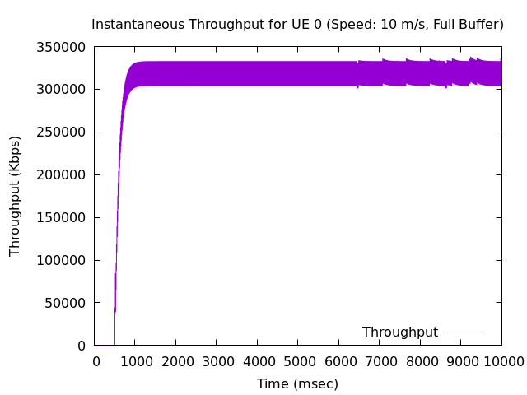

**Graph 6**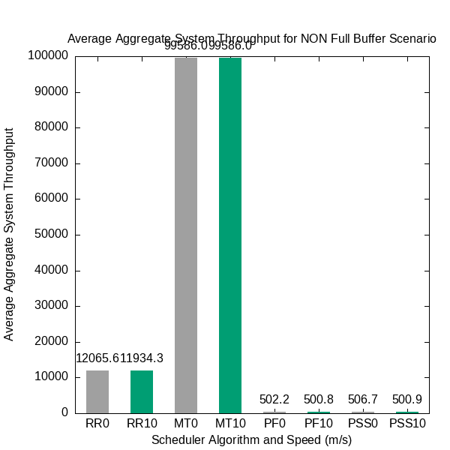

**Conclusion:**

The results of this simulation show that the PF scheduler algorithm is a good choice for LTE networks where high throughput is required for all UEs, even in full buffer scenarios and at high speeds. However, the average system throughput can be improved by using a non-full buffer scenario.

The results show that the PF scheduler algorithm outperforms the RR scheduler algorithm in both full buffer and non-full buffer scenarios. This is because the PF scheduler algorithm dynamically allocates resources to UEs based on their channel conditions and queue lengths, while the RR scheduler algorithm allocates resources to UEs in a round-robin manner.

The results also show that the average aggregate system throughput increases with speed. This is because the higher the speed, the more data can be transmitted over a given period of time.

However, the average aggregate system throughput for the non-full buffer scenario is higher than the average aggregate system throughput for the full buffer scenario. This is because the eNodeB has more resources available to allocate to UEs in a non-full buffer scenario.

**Graph of just SINR for other algorithms**

**The other graphs could be found in the repository along with the data.**

**Here is a graph for SINR in RR**

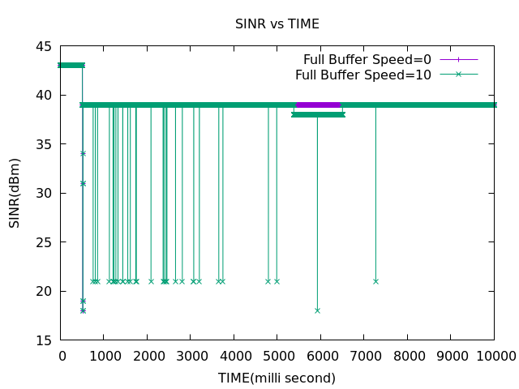

**Here is a graph for SINR in PSS**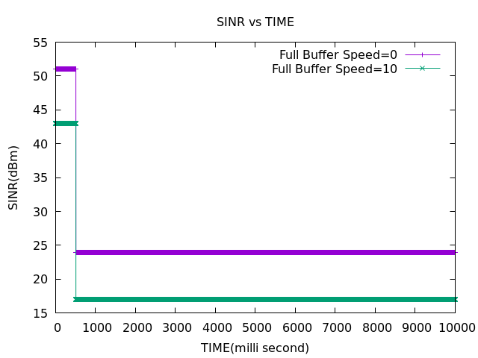

**Here is a graph for SINR in MT**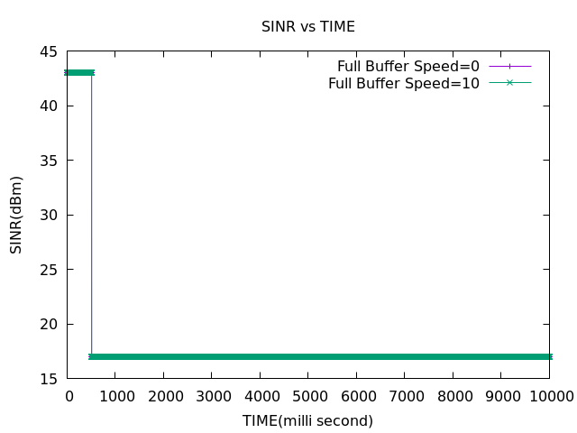

**References:**

[1] NS-3 Network Simulator: <https://www.nsnam.org/>

[2] LTE Simulator: <https://ns3simulation.com/lte-simulation-ns3/>

[3] Proportional Fair Scheduler: <https://en.wikipedia.org/wiki/Proportional-fair_scheduling>